IFG Adventure 3rd Year

Term Two – Weeks Two, Three & Four Artz Interest

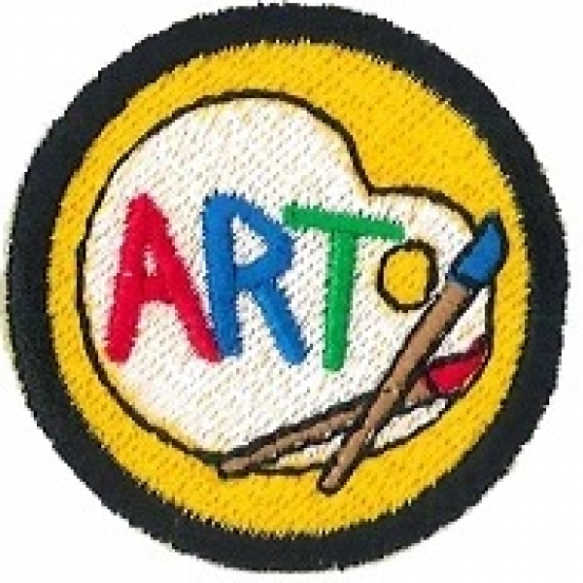
On completion of this three week programme the girls will have earned their Artz badge.

Aim:
- To teach the girls skills to enable them to create various artworks using different types of media ie sculpture; carving stone or bone;
clay work; pottery; painting on canvas, media arts ie video production etc.

Objectives:
- To have the girls learn about the equipment/ materials required and skills necessary for pursuing different media in the various fields of the Arts.

Preparation:
- Enlist the help of recognized local experts in their chosen field as your instructors
- Choose people who are able to inspire and motivate girls in this age bracket and who will instruct and oversee these activities with flare, enthusiasm and sensitivity.
- Notice to parents about the activities, place of activity and clothing required.

Teaching Points:
Instruction should cover
- Correct use and maintenance of equipment
- Safety – Using the equipment and any extra specific equipment required for safety

SetUp:
Take your Master Roll with you if going off site. Mark the roll at the commencement of the evening.

Devotion:
Bible verses based on the making of garments or the goldsmiths and silversmiths could be used.

Teaching Session/Activity:
Ensure the girls not only practice the skills but also get to produce their own pieces of art.

Closing Prayer

Notices & home time:

